1. SELECT * FROM barang;

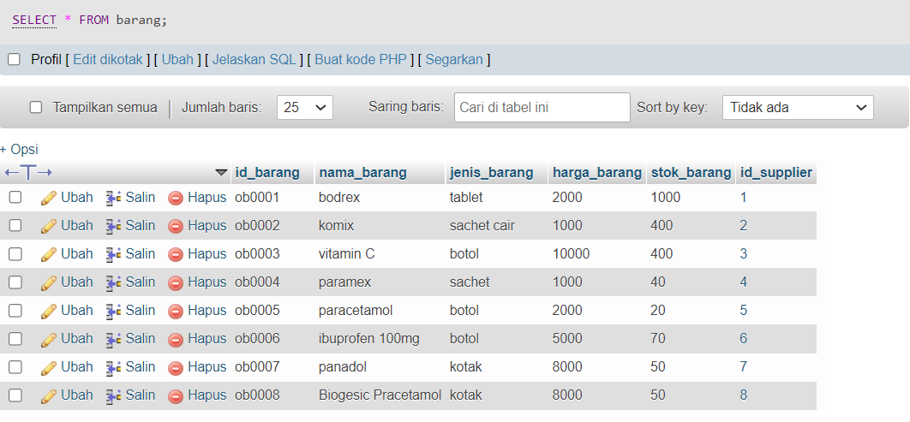

1. SELECT nama_barang FROM barang;

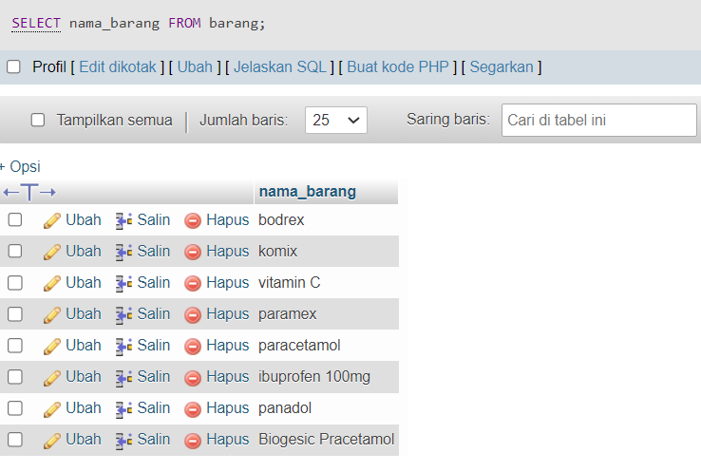

1. SELECT * FROM barang WHERE harga_barang = 2000;

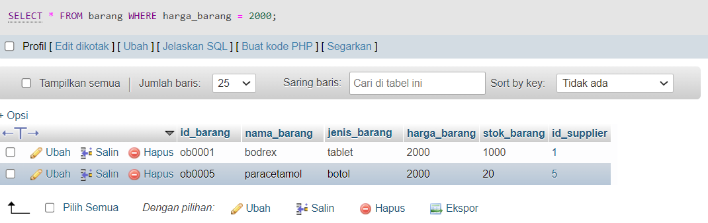

1. SELECT * FROM barang WHERE jenis_barang <> "botol";

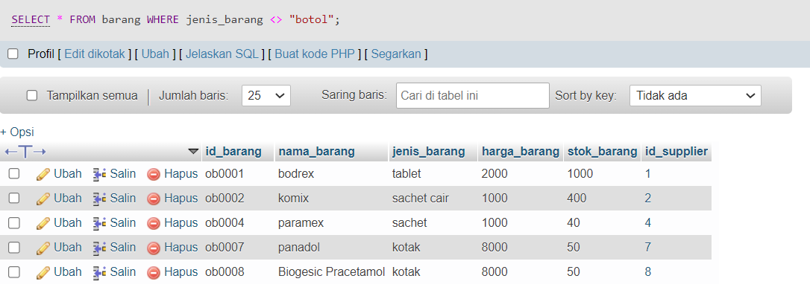

1. SELECT * FROM barang WHERE harga_barang > 8000;

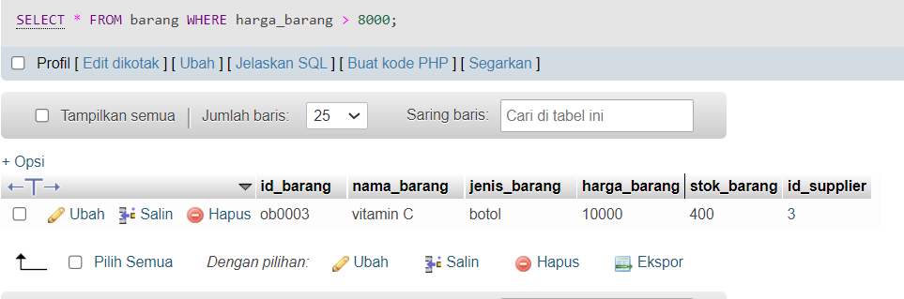

1. SELECT * FROM barang WHERE stok_barang < 70;

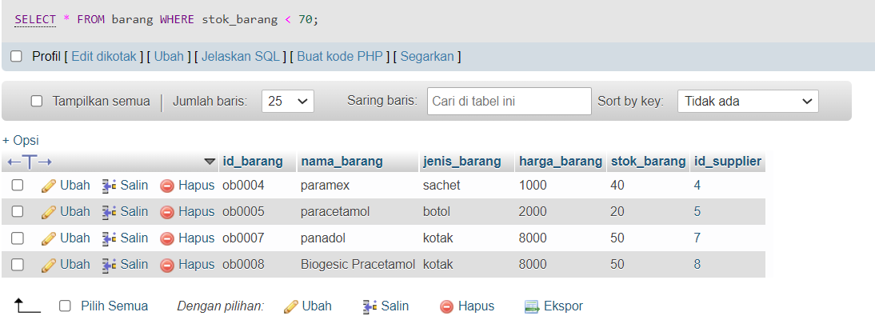

1. SELECT * FROM barang WHERE harga_barang >= 8000;

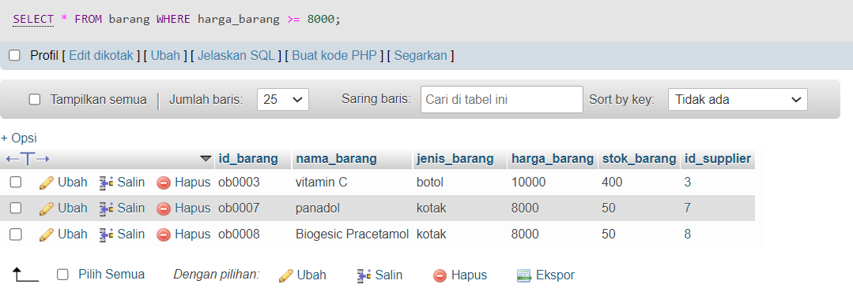

1. SELECT * FROM barang WHERE harga_barang <= 8000;

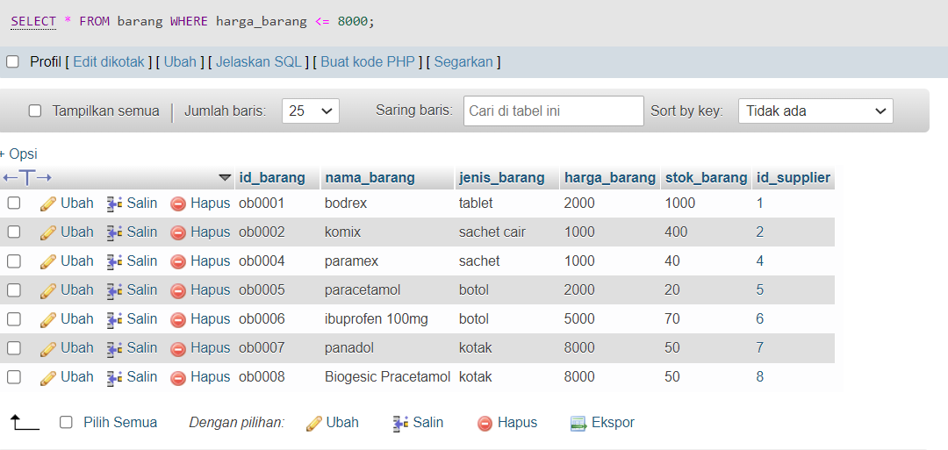

1. SELECT * FROM barang WHERE stok_barang BETWEEN 20 AND 70;

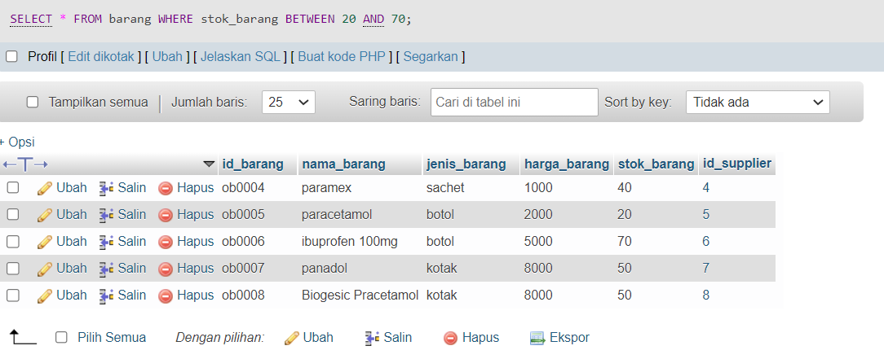

1. SELECT * FROM barang WHERE nama_barang LIKE "pa%";

